City Of Calgary.
GCP Landing Zone Design & Implementation Document
Version 1.0
Document tracking
Revision history
Version | Author(s) | Description
1.0 | Gavin Singh | Initial Document

Reviews and approvals
Version | Reviewer(s) | Comments

Table of contents
Table of contents 3
1 Introduction 5
1.1 Executive Summary 5
1.2 Scope 5
1.3 Document Note 6
2 Key architectural decisions 7
3 Cloud Identity 8
3.1 Cloud Identity overview 8
3.2 IAM design and implementation 9
4 Billing 10
4.1 Billing account overview and design 10
4.2 Budget alerts overview and design 11
4.3 Billing exports overview, design, and implementation 13
5 Resource Hierarchy 14
5.1 Organization & resources hierarchy overview 14
5.2 Naming conventions 14
5.3 Resource hierarchy design 15
5.4 Organization policies implementation 17
6 Networking 17
6.1 Shared VPC overview 17
6.2 Shared VPC design 18
6.3 Firewalls rules overview and design 19
6.4 Firewall policies overview and design 19
6.5 VPN overview 20
6.6 VPN design 21
7 Monitoring and Logging 21
7.1 Cloud monitoring overview and design 21
7.2 Cloud logging overview and design 22
8 Security 23
Security command center overview and design 23
9 Google Cloud VMware Engine 24
9.1 GCVE Management Network 24
9.2 VMware Engine to VPC connectivity 24
9.3 Cloud VMware Engine IAM roles 25
10 Acronyms 25
11 Acknowledgement of Implementation 26

- Introduction
1.1 Executive Summary
This document provides the detailed design & implementation for City Of Calgary Google Cloud Landing Zone. The objective is to detail the infrastructure and security architecture of the landing zone as well as document the key decisions and rationale which supports the overall design.
The intended audiences of this document are Architects, Security Architects and Cloud Engineers, to support the implementation of the landing zone.

1.2 Scope
Here are the scopes of this project regarding the design and implementation of landing zone:
Cloud Identity Integration with Microsoft Entra
- The design and implementation strategy for integrating Microsoft Entra ID (formerly Azure AD) with Google Workspace for the City of Calgary. The solution will enable Single Sign-On (SSO) authentication and automated user provisioning from Entra ID to Google Workspace.
  - Configure Cloud Identity
  - Consolidate 20 suspended unmanaged Google accounts under calgary.ca domain
  - Implement SSO using Entra ID as the identity provider
  - Automate user provisioning and lifecycle management
  - Establish appropriate licensing strategy for Cloud Identity Premium
  - Enable future Gemini access for select users using Vertex AI.

Landing Zone Deployment
- Leveraging Terraform Infrastructure as code to deploy Landing Zone that leverage blueprints templates to automate the deployment of a new Google Cloud environment.
  - Set up Organization node and folder structure
  - Create new Projects
  - Create service accounts
  - Link City of Calgary billing account to Google Cloud Partner
  - Resource Management configuration
  - Enable monitoring and logging
  - Configure initial organizational security settings
  - Resource Management configuration
  - Execute the IaC blueprints that will deploy the initial Landing Zone

- Document Note
At the time of writing, the architect has made assumptions regarding information technology knowledge and skill level of the audience reviewing this document. This document refers to terms, acronyms, and specialized product jargons; where it is relatively brief to do so, these items are defined or expanded in-line with the text and context of the subject matter presented. Longer definitions and explanations can be found in the Acronym section.

- Key architectural decisions
Organization structure | A single organization is used for all environments and services for the City of Calgary to manage all resources and policies in one place.
Organization structure | The folder hierarchy has a single layer, consisting of Fldr-WWL-bootstrap, Fldr-WWL-billing, Fldr-WWL-POC folders to allow for segregation of policies, privileges, and access.
Organization structure | Google Cloud organization policies is used to augment the organization's security posture by defining resource configuration constraints that apply consistently across all projects.
Resource deployment | Terraform is used as the infrastructure as code (IaC) tool.
Resource deployment | The IAC deployment's actions are initiated from the work-station environment.
Resource deployment | Terraform state is stored in bkt-terraform-landingzone cloud storage bucket in the prj-WWL-bootstrap project.
Identity and IAM | Azure AD is the source of truth for user provisioning and management, users are federated with Cloud Identity.
Identity and IAM | Cloud IAM roles are assigned to groups instead of individuals.
Identity and IAM | Users are synced from Azure AD, but permissions are assigned in GCP IAM
Networking | Shared VPC is used as the primary networking topology to enable centralized management of firewall rules and connectivity.
Networking | No custom firewall rules were created for controlling network traffic flows.
Logging | Folder-level log sinks are used to aggregate logs with severity level warning or above.
Logging | Aggregated logs in a folder with severity warning or above are sent to a centralized Cloud Log Bucket.
Detective Controls | Security Command Center standard is enabled to detect infrastructure misconfigurations, vulnerabilities, and active threat behavior.
Billing | Centralize billing into one account connected to Softchoice billing.
Billing | One budget alert is created on a per folder basis with thresholds set at 75%, 90%, 100%, and 120% of last month’s spent.

- Cloud Identity
  - Cloud Identity overview
Cloud Identity is an Identity as a Service (IDaaS) solution offered by Google that centrally manages users and groups. It can be configured to federate identities between Google and other identity providers, such as Okta, Active Directory, and Azure Active Directory. Cloud Identity configurations are made in the Admin Console.
There are two types of user accounts in cloud identity, consumer accounts are user accounts with domains which are unmanaged like Gmail.com, and managed accounts belong to an organization and are controlled by its administrators. User accounts in cloud identity use a primary email address for identification. However, managed accounts can also have an alias email address and a recovery email address, these email addresses cannot be used for sign in but may be used for account-related actions. The domain of the primary email address must correspond to the domain of a Cloud Identity in a Google Workspace account.
For the City of Calgary, Cloud Identity will be federated with Azure AD as the authoritative source. Users and selected groups will authenticate via SAML, with group memberships managed in Azure.

Table 3.1.1. City of Calgary current Azure AD configuration
Active Directory Setup
Domains exist in active directory? | Yes
Are the on-premises Active Directory domains synchronized with Microsoft Entra ID | Yes
Users Provisioning
Common identifiers for users?  (a) Email addresses  or  (b) User Principal Names (UPNs) | UPN
Are all users part of the group?  Individual users that need to be provisioned? | yes
How many domains are used by email address? | 1
Are there any users that exists in both ~ Google Workspace & Azure-AD? | Need to check
Do you have unmanaged users with domains like onmicrosoft.com? | no
Groups Provisioning
Groups are provisioned by?  (a) By Email address (team@company.com )  or  (b) By name? (Marketing Team) | name
How many domains used by email address? | 1
Do you plan to provision all groups to Google Cloud or only a select subset of groups? | Currently a subset
Does SSO needs to be enabled for all users? | Yes, subset of group
Azure Active Directory Setup
Domains exist in active directory? | yes
Account with Enterprise admin access? | admin
Ip address of the current onprem domain controller? | N/A
IP address of the DNS server? | N/A
Firewalls ON prem that may block the connections from GCP? | N/A

Table 3.1.1. Groups to be federated for City of Calgary
Group Name | Group Email | Users
Billing Admin | Billingadmin_gp@calgary.ca | Managed by Azure Admin
Billing Viewer | Billingviewer_gp@calgary.ca | Managed by Azure Admin
Organization Admin | Orgadmin_gp@calgary.ca | Managed by Azure Admin

  - IAM design and implementation
Table 3.2.1. IAM Organizational Group for WWL
Group Name | Scope  - Suggested Roles | Purpose | Suggested Personnel
Billing Admin | Organization  - Browser  Softchoice managed billing account  - Billing Account Admin | Manages billing account IAM permissions | Organization Admin
Billing Viewer | Organization  - Browser  Softchoice managed billing account  - Billing Account Viewer | View billing data | Finance team / Accounts payable
Organization Admin | Organization  - Owner  - Folder Admin  - Organization Administrator  - Organization Policy Admin  - Compute SharedVPC Admin  - Project Mover  Softchoice managed billing account  - Billing Account User  - Billing Account Viewer  - Billing Account Costs Manager | Manage day to day operation of GCP environment. Able to create, delete, and manage permissions, projects, and resources across the entire organization | IT team
POC Admin | Organization  - Browser  Fldr-WWL-POC Folder  - Owner  - Project Creator  - Project Deleter  - Project IAM Admin  - Compute SharedVPC Admin  - VMware Engine Service Admin  Softchoice managed billing account  - Billing Account User  - Billing Account Viewer  - Billing Account Costs Manager | Manage day to day operation of POC environment. Able to create, delete, and manage permissions, projects, networks, and resources across the entire POC environment. | POC GCVE Admins
POC User | Organization  - Browser (Optional)  Department Folder  - Editor  - VMware Engine Service Viewer  Softchoice managed billing account  - Billing Account Viewer | Able to create, delete, and manage resources located within the POC environment. | POC GCVE Users

- Billing
  - Billing account overview and design
In Google Cloud, resource and service spending are paid via a billing account which is linked to a payments profile. A Cloud Billing account is set up in Google Cloud and is used to define who pays for a given set of Google Cloud resources and Google Maps Platform APIs. Access control to a Cloud Billing account is established by IAM roles scoped to the Billing account. Google payments profile includes a payment instrument to which costs are charged. As stated in the statement of work, Softchoice will provide managed Billing service to WWL.
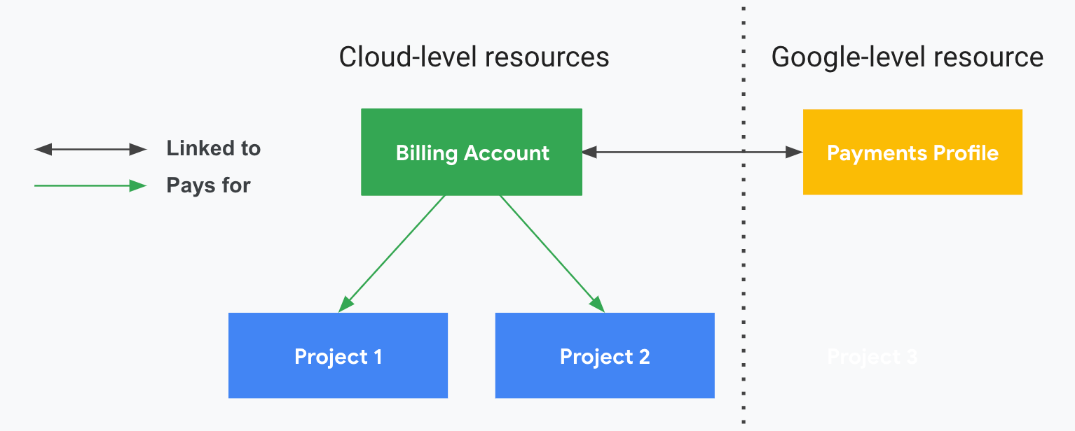
Figure 4.1.1. Billing Account and Payments Profile relationship example

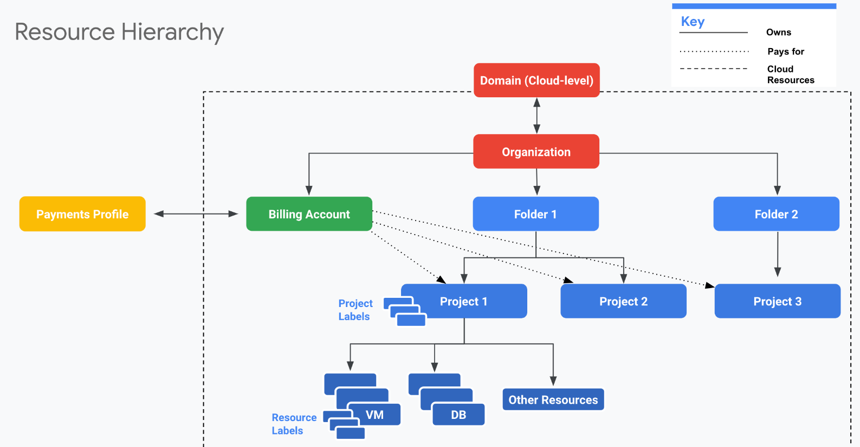
Figure 4.1.2. Billing and Resource Hierarchy relationship example

  - Budget alerts overview and design
Cloud Billing budgets can monitor all of Google Cloud charges in one place. It enables tracking of actual Google Cloud spending against planned spending. After a budget amount is set, budget alert threshold rules can be set to trigger email notifications in case the planned budget is exceeded. With Cloud Billing budgets, the following options can be configured to track budget alerts:
- Time period of budget
- Scope of budget
- Specified budget total amount or based on previous calendar period
- Threshold which alert is triggered
- Recipients of email alerts
- Pub/Sub for programmatic notifications
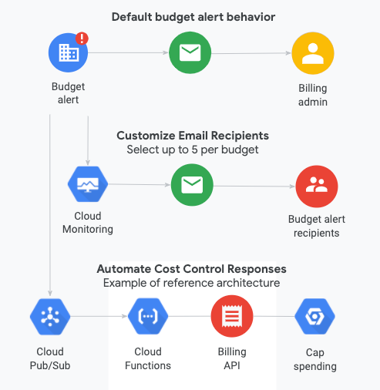
Figure 4.2.1. Billing Budget Alert behavior visualized.

For the landing zone, the following design will be implemented by Softchoice. Table 4.2.1. showcase a template for the budget alerts that will apply to all projects in an organization while Table 4.2.2. lists the for the budget alert. Please note, the recipient billing_admin@wwl.com, which is the Billing Admin, will be notified when the budget is exceeded. To add new projects to an existing budget alert, one can edit an existing budget alert configuration after it has been created.

Table 4.2.1. Budget Alert configuration template
Configuration Template | Value
Time period of budget | 1 Calendar Period (end of each month)
Scope of budget | Projects under each department
Budget total amount | Last month’s spend
Threshold which alert is triggered | 75%, 90%, 100%, 120%
Recipients of email alerts | Billing Admins
Pub/Sub for programmatic notifications | Not used

Table 4.2.2. Budget Alert configurations
Budget Alert Name | Initial budget alert projects | Recipients
Ba-WWL-organization-lastmonthspend | All projects inside the organization | Billingadmin_gp@wwlinc.com

  - Billing exports overview, design, and implementation
Cloud Billing export to BigQuery enables detailed Google Cloud billing data (such as usage, cost estimates, and pricing data) to be exported automatically throughout the day to a BigQuery dataset. The Cloud Billing data from BigQuery can then be accessed for detailed analysis or visualized using a tool like Google Data Studio. Once billing has been set up, Softchoice will set up standard and pricing billing export to a BigQuery dataset located in prj-WWL-billing for analysis.

Table 4.3.1. Billing export configuration design
BigQuery dataset | Billing account to be exported
Bq-WWL-organization-billing | 013DE6-51CF0F-23A1C2

- Resource Hierarchy
  - Organization & resources hierarchy overview
The organization resource is the root node of the Google Cloud resource hierarchy, which consists of folders, projects, and resources. It defines the shape and use of Google Cloud services within an organization. Policies are inherited from top to bottom and cannot be altered by resource owners who are lower in the hierarchy.
Benefits of the Organization resource
- With an organization resource, projects belong to WWL organization instead of the employee who created the project.
- Organization administrators have central control of all resources.
- Can grant roles at the organization level, which are inherited by all projects and folders under the Organization resource.
Folders are used as a method of grouping projects into related groups. Security policies can be applied and access permissions at the folder level; these policies and permissions are inherited by resources within the folder structure.
Projects contain cloud resources. Each project inherits the policy of the parent folder or folders and of the Google Cloud organization. APIs can be enabled or disabled within each project to support the services that are needed for that project. Each project is associated with a billing account. For example:
- Host project (Shared) contains the Shared VPC networks.
- Service projects are attached to a Shared VPC host project. Service projects are used by WWL for production, non-production, and development.

  - Naming conventions
A good naming convention should be in place before creating any Google Cloud resources. A naming convention ensures that all the resources will have a predictable name, which helps lower the administrative burden associated with management of those resources. Table 5.3.1 describes recommended conventions for creating Google Cloud element names for the Weldon, Williams & Lick, Inc. landing zone architecture.
Table 5.2.1. Suggested naming convention for WWL organizational resources

Environment Codes
Code | Environment | Description
prd | Production | Live production environment
stg | Staging | Pre-production testing
uat | UAT | User acceptance testing
dev | Development | Development environment
tst | Test | Testing environment
sbx | Sandbox | Experimental/sandbox

Common Resource Abbreviations
Abbreviation | GCP Resource | Azure Equivalent
vm | Compute Engine VM | Virtual Machine
vpc | VPC Network | Virtual Network (vnet)
gke | Google Kubernetes Engine | AKS
run | Cloud Run | Container Apps
func | Cloud Functions | Azure Functions
gae | App Engine | App Service
bkt | Cloud Storage Bucket | Storage Account
fs | Filestore | Azure Files
mysql | Cloud SQL MySQL | Azure MySQL
pgsql | Cloud SQL PostgreSQL | Azure PostgreSQL
bt | Bigtable | Cosmos DB
bq | BigQuery | Synapse Analytics
pubsub | Pub/Sub | Service Bus
df | Dataflow | Stream Analytics
lb | Load Balancer | Load Balancer
fw | Firewall Rule | NSG
nat | Cloud NAT | NAT Gateway
vpngw | VPN Gateway | VPN Gateway
eip | External IP | Public IP
psc | Private Service Connect | Private Endpoint
sa | Service Account | Managed Identity
kms | Cloud KMS | Key Vault
sm | Secret Manager | Key Vault Secrets
ar | Artifact Registry | Container Registry
ig | Instance Group | Availability Set
mig | Managed Instance Group | VM Scale Set
snap | Snapshot | Snapshot

GCP Component | Azure Equivalent | GCP Naming Convention | GCP Example | Explanation | GCP Naming Constraints
Compute Engine VM | Virtual Machine | env-workload-vm-instance | prd-dc-vm-01 | Production, Domain Controller, VM, Instance | Lowercase, hyphens, 1-63 chars, start with letter
Persistent Disk (Boot) | OS Disk | vmname-boot-instance | prddc01-boot-01 | VM Name, Boot Disk, Instance | Lowercase, hyphens, 1-63 chars
Persistent Disk (Data) | Data Disk | vmname-data-instance | prddc01-data-01 | VM Name, Data Disk, Instance | Lowercase, hyphens, 1-63 chars
Instance Group | Availability Set | env-workload-ig-instance | prd-dc-ig-01 | Production, Workload, Instance Group, Instance | Lowercase, hyphens, 1-63 chars
Managed Instance Group | VM Scale Set | env-workload-mig-instance | dev-cmg-mig-01 | Development, Workload, MIG, Instance | Lowercase, hyphens, 1-63 chars
VPC Network | Virtual Network | env-workload-vpc-instance | dev-synapse-vpc-01 | Development, Function, VPC, Instance | Lowercase, hyphens, 1-63 chars
VPC Subnet | Subnet | env-workload-subnet-region | dev-synapse-subnet-cc | Development, Function, Subnet, Region (cc=canada-central) | Lowercase, hyphens, 1-63 chars
Cloud VPN Gateway | Virtual Network Gateway | env-workload-vpngw-instance | dev-synapse-vpngw-01 | Development, Function, VPN Gateway, Instance | Lowercase, hyphens, 1-63 chars
External IP Address | Public IP Address | env-workload-eip-instance | dev-synapse-eip-01 | Development, Function, External IP, Instance | Lowercase, hyphens, 1-63 chars
VPN Tunnel | Connection/Tunnel | env-workload-tunnel-target | prd-synapse-tunnel-onprem | Production, Function, Tunnel, Target | Lowercase, hyphens, 1-63 chars
External VPN Gateway | Local Network Gateway | env-workload-peergw-instance | prd-synapse-peergw-01 | Production, Function, Peer Gateway, Instance | Lowercase, hyphens, 1-63 chars
Cloud Router | Route Table | env-workload-router-instance | dev-managed-router-01 | Development, Function, Router, Instance | Lowercase, hyphens, 1-63 chars
Firewall Rule | Network Security Group | env-workload-fw-direction-action | dev-web-fw-ingress-allow | Development, Workload, FW, Direction, Action | Lowercase, hyphens, 1-63 chars
Cloud Load Balancing | Load Balancer | env-workload-lb-instance | dev-ecomm-lb-01 | Development, Function, Load Balancer, Instance | Lowercase, hyphens, 1-63 chars
Cloud NAT | NAT Gateway | env-workload-nat-instance | dev-synapse-nat-01 | Development, Function, NAT, Instance | Lowercase, hyphens, 1-63 chars
Private Service Connect | Private Endpoint | env-workload-psc-instance | dev-database-psc-01 | Development, Function, PSC, Instance | Lowercase, hyphens, 1-63 chars
Cloud DNS Zone | Private DNS Zone | env-workload-dns-instance | dev-internal-dns-01 | Development, Function, DNS, Instance | Lowercase, hyphens, 1-63 chars
Cloud CDN | Front Door / CDN | env-workload-cdn-instance | dev-csc-cdn-01 | Development, Function, CDN, Instance | Lowercase, hyphens, 1-63 chars
Cloud Storage Bucket | Storage Account | env-workload-bkt-instance | prdsynapsebkt01 | Production, Workload, Bucket, Instance | Globally unique, 3-63 chars, lowercase, no underscores
Filestore | Azure Files | env-workload-fs-instance | dev-app-fs-01 | Development, Function, Filestore, Instance | Lowercase, hyphens, 1-63 chars
Cloud SQL (MySQL) | Azure Database for MySQL | env-workload-mysql-instance | dev-c3m-mysql-01 | Development, Function, MySQL, Instance | Lowercase, hyphens, 1-98 chars
Cloud SQL (PostgreSQL) | Azure Database for PostgreSQL | env-workload-pgsql-instance | dev-app-pgsql-01 | Development, Function, PostgreSQL, Instance | Lowercase, hyphens, 1-98 chars
Cloud SQL (SQL Server) | SQL Database | env-workload-sqlserver-instance | dev-remedy-sqlserver-01 | Development, Function, SQL Server, Instance | Lowercase, hyphens, 1-98 chars
AlloyDB | Azure Cosmos DB for PostgreSQL | env-workload-alloydb-instance | dev-analytics-alloydb-01 | Development, Function, AlloyDB, Instance | Lowercase, hyphens, 1-63 chars
Spanner | Azure Cosmos DB | env-workload-spanner-instance | dev-global-spanner-01 | Development, Function, Spanner, Instance | Lowercase, hyphens, 2-30 chars
Firestore | Cosmos DB (Document) | env-workload-firestore | dev-app-firestore | Development, Function, Firestore | Project-level, single database per mode
Bigtable | Cosmos DB (Key-Value) | env-workload-bt-instance | dev-iot-bt-01 | Development, Function, Bigtable, Instance | Lowercase, hyphens, 6-33 chars
Memorystore (Redis) | Azure Cache for Redis | env-workload-redis-instance | dev-cache-redis-01 | Development, Function, Redis, Instance | Lowercase, hyphens, 1-40 chars
BigQuery Dataset | Synapse Analytics / SQL Database | env_workload_dataset | prd_synapse_analytics | Production, Workload, Dataset | Lowercase, underscores, 1-1024 chars
Dataproc Cluster | HDInsight / Databricks | env-workload-dataproc-instance | dev-synapse-dataproc-01 | Development, Function, Dataproc, Instance | Lowercase, hyphens, 1-55 chars
Pub/Sub Topic | Event Hubs / Service Bus | env-workload-topic-instance | dev-iot-topic-01 | Development, Function, Topic, Instance | 3-255 chars, start with letter
Pub/Sub Subscription | Event Hubs Consumer | env-workload-sub-instance | dev-iot-sub-01 | Development, Function, Subscription, Instance | 3-255 chars, start with letter
Dataflow Job | Stream Analytics | env-workload-df-instance | dev-etl-df-01 | Development, Function, Dataflow, Instance | Lowercase, hyphens, 1-40 chars
Cloud Composer | Data Factory | env-workload-composer-instance | dev-orchestration-composer-01 | Development, Function, Composer, Instance | Lowercase, hyphens, 1-63 chars
Cloud Run Service | App Service / Container Apps | env-workload-run-instance | dev-api-run-01 | Development, Function, Cloud Run, Instance | Lowercase, hyphens, 1-63 chars
Cloud Functions | Azure Functions | env-workload-func-instance | dev-integration-func-01 | Development, Function, Cloud Functions, Instance | Lowercase, hyphens, 1-63 chars
App Engine | App Service | env-workload-gae | dev-web-gae | Development, Function, App Engine | Project-level service
Workflows | Logic Apps | env-workload-workflow-instance | dev-invoiceupload-workflow-01 | Development, Function, Workflow, Instance | Lowercase, hyphens, 1-64 chars
Cloud Scheduler | Azure Scheduler / Logic Apps | env-workload-scheduler-instance | dev-backup-scheduler-01 | Development, Function, Scheduler, Instance | Lowercase, hyphens, 1-500 chars
Cloud Tasks | Queue Storage | env-workload-tasks-instance | dev-async-tasks-01 | Development, Function, Tasks, Instance | Lowercase, hyphens, 1-100 chars
GKE Cluster | AKS | env-workload-gke-instance | dev-microservices-gke-01 | Development, Function, GKE, Instance | Lowercase, hyphens, 1-40 chars
Artifact Registry | Container Registry | env-workload-ar-instance | dev-images-ar-01 | Development, Function, Artifact Registry, Instance | Lowercase, hyphens, 1-63 chars
Vertex AI Workbench | Azure Machine Learning | env-workload-vertexai-instance | dev-ml-vertexai-01 | Development, Function, Vertex AI, Instance | Lowercase, hyphens, 1-63 chars
Cloud Vision API | Computer Vision | N/A (API-based) | N/A | API service, no resource naming | API-based service
Cloud Natural Language | Language Service | N/A (API-based) | N/A | API service, no resource naming | API-based service
Speech-to-Text | Azure Speech Service | N/A (API-based) | N/A | API service, no resource naming | API-based service
Dialogflow | Bot Service / LUIS | env-workload-dialogflow-instance | dev-chatbot-dialogflow-01 | Development, Function, Dialogflow, Instance | Lowercase, hyphens
Secret Manager Secret | Key Vault Secret | env-workload-secret-name | dev-api-secret-dbpassword | Development, Function, Secret, Name | Lowercase, hyphens, 1-255 chars
Cloud KMS Key Ring | Key Vault | env-workload-keyring-instance | dev-encryption-keyring-01 | Development, Function, Key Ring, Instance | Lowercase, hyphens, 1-63 chars
Cloud KMS Key | Key Vault Key | env-workload-key-purpose | dev-storage-key-encrypt | Development, Function, Key, Purpose | Lowercase, hyphens, 1-63 chars
Service Account | Managed Identity | env-workload-sa@project.iam | dev-app-sa@myproject.iam.gserviceaccount.com | Development, Workload, SA @ Project | 6-30 chars before @
IAM Role | Azure Role | roles/service.roleName | roles/storage.objectViewer | Service, Role Name | Predefined or custom roles
Cloud Monitoring Workspace | Log Analytics Workspace | env-workload-monitoring-instance | dev-infra-monitoring-01 | Development, Function, Monitoring, Instance | Project-scoped
Cloud Logging Log Sink | Diagnostic Settings | env-workload-sink-instance | dev-audit-sink-01 | Development, Function, Sink, Instance | Lowercase, underscores, 1-100 chars
Cloud Trace | Application Insights | N/A (Automatic) | N/A | Automatic tracing | Project-scoped, automatic
GCP Project | Subscription | env-bu-workload-prj | prd-it-network-prj | Production, Business Unit, Function, Project | 6-30 chars, globally unique ID
GCP Folder | Resource Group | env-bu-folder | prd-it-folder | Production, Business Unit, Folder | Display name, 1-30 chars
GCP Organization | Management Group / Tenant | domain.com | mycompany.com | Domain-based organization | Tied to Cloud Identity domain
Backup Plan | Recovery Services Vault | env-workload-backup-instance | dev-vm-backup-01 | Development, Function, Backup, Instance | Lowercase, hyphens
Snapshot | Snapshot | env-workload-snap-timestamp | dev-db-snap-20241215 | Development, Function, Snapshot, Timestamp | Lowercase, hyphens, 1-63 chars
Custom Image | VM Image | os-version-workload-instance | ubuntu2204-web-01 | OS, Version, Workload, Instance | Lowercase, hyphens, 1-63 chars

Resource | Naming Convention | Example
Folder | fldr-environment | fldr-prod
Project | prj-environment-internal/external business unit | prj-prod-int-it
VPC | environment-workload-resource-instance | prod-synapse-vpc-01
Subnet | environment-workload-resource-instance | prod-synapse-subnet-01
Firewall | fw-{vpc-name}-priority-direction-action-src-label-dest-label-protocol-port-{firewall-label} | Fw-prod-shared-base-1000-i-a-all-all-tcp-80
Cloud Router | cr-{vpc-name}-region{-cloud-router-label} | cr-prod-shared-base-us-east1-cr1
Route | rt-{vpc-name}-priority-instance-tag-next-hop-{route-label} | Rp-prod-shared-base-1000-all-default-windows-activation
Cloud Interconnect connection | ic-source-destination-coloation | Ic-dal-lga-zone1-1422
Cloud Interconnect VLAN attachment | vl-ic-name-cr-name | Vl-dal-da1-zone1-p-shared-base-us-east1-cr1
Group | Grp-business-group-label | Grp-gcp-billing-admin
Role | Rl-function-{role-label} | Rl-compute-admin
VPN gateway | Vgate-Business-“src_env”-“dest_env”-region-VPNgateway | Vgate-WWL-onprem-staging-USEAST1-vpngateway
VPN tunnel | Vtun-Business-“src_env”-“dest_env”-region-VPNtunnel-{type of VPN}-label | Vtun-WWL-onprem-staging-USEAST1-vpntunnel-classic-1
BudgetAlert | Ba-Business-scope-type | Ba-WWL-organization-lastmonthspend
BigQuery dataset | Bq-Business-environment-purpose | Bq-WWL-shared-billing
GKE | Gke-Business-environment-region | Gke-WWL-staging-USEAST1
Log Router | LS-Business-environment-region | LS-WWL-POC-USWEST2
Logging Storage Bucket | Lsb-Business-"bucket _Business"-"logging_scope"-"types_of_logs" | Lsb-WWL-shared-organization-alllogs
Service Account | sa-{service-account}-label | sa-bkt-reader
Storage Bucket | bkt-project-name-{bucket-label} | bkt-WWL-POC-data

  - Resource hierarchy design
To design an efficient and secure GCP organization structure for Weldon, Williams & Lick, Inc., a clear hierarchy of resources will be established to prevent accidental deletion or updates to resources outside of their intended scope. The following GCP Organization hierarchy was designed as shown in Figure 5.3.1. Under the root organization, WWL.com, three separate folders will be created, bootstrap, billing, and POC. The POC environment has its own network infrastructure project, and its own cloud operations project. This will allow resources in the POC folder to share a common network infrastructure for easier management. Table 5.3.1 showcases this organization resource hierarchy in a table format while table 5.3.2. will further reflect the purpose of each project to ensure their use case is fully understood.

Table 5.3.1. WWL Organization resource hierarchy with sample resources
Organization | WWL Organization
Folders | Fldr-WWL-bootstrap | Fldr-WWL-billing | Fldr-COC-<ENV>
Projects | Prj-WWL-bootstrap | Prj-WWL-billing | Prj-WWL-POC-SharedVPC  Prj-WWL-POC-Shared-Log-Monitor  Prj-WWL-POC-Infra
Sample Resources | Cloud storage | BigQuery Dataset | Cloud Logging  Cloud Monitoring  Shared-VPC  GCVE

Table 5.3.2. Breakdown of each landing zone project’s purpose in WWL’s organization
Project name | Purpose
Bootstrap | Initial landing zone deployment project
Prj-WWL-Billing | Stores billing logs, billing related BigQuery datasets and other billing related resources
Prj-WWL-POC-Log-Monitor | Hosts log storage buckets for all projects and Monitoring Dashboard
Prj-WWL-POC-SharedVPC | Hosts shared VPC networks
Prj-WWL-POC-Infra | Hosts GCVE

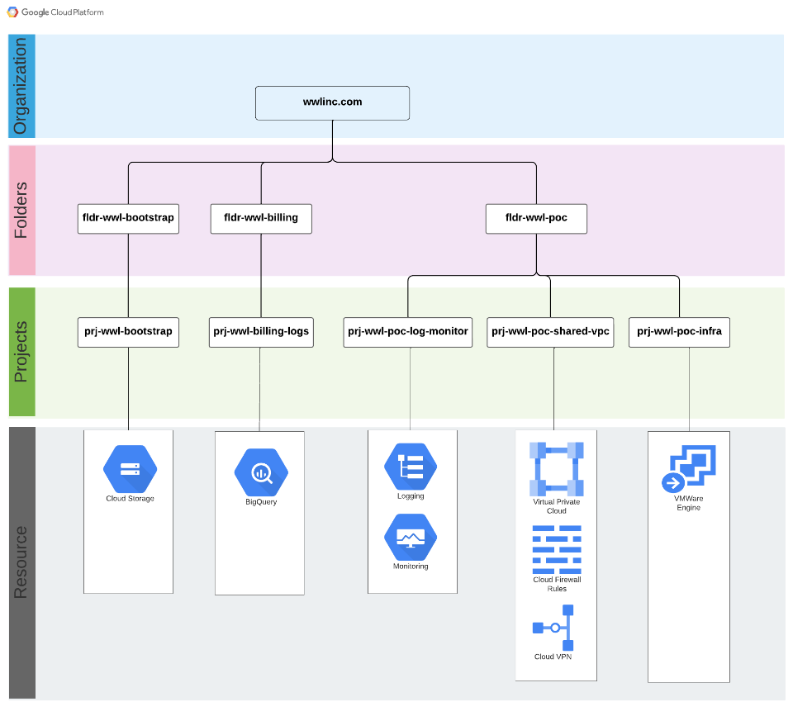
Figure 5.2.1. Softchoice’s GCP Landing zone design for WWL
  - Organization policies implementation
To improve organization security and process uniformity, certain organization policies were placed on WWL’s resource hierarchy at the organization level to enforce certain restrictions. Table 5.4.1 contains a list of organization policies placed on WWL's organization with reasonings attached.

Table 5.4.1. Organization Polices to be added for WWL
Organization Policy | Description | Reasoning | Scope
Restrict shared VPC project lien removal | Restrict shared VPC project lien removal, which prevents the shared VPC project from being deleted unless a user is authorized by this policy. | This policy prevents the shared VPC project from accidentally or maliciously deleted. | Organization
Skip default network creation | Skips the creation of default network when a project is created | Prevents creation of default networks which assigns a subnet for each region. A subnet for each region is unnecessary and adds additional management overhead. | Organization
Domain Restricted Sharing | This list constraint defines one or more Cloud Identity or Google Workspace customer IDs whose principals can be added to IAM policies. | Constrains a list of members which can be added to your organization's IAM policy. | Organization
Restrict VPN Peer IPs | Constrains a set of valid IPv4 addresses which VPN peering can be established. | Prevents unauthorized VPN peering from IPv4 addresses not listed in the organization policy. | Organization
Enforce Public Access Prevention | When enforced, this policy prevents public access to your GCS storage buckets. | By preventing public access to GCS buckets, data is kept safe from unauthorized downloads. | Organization

- Networking
  - Shared VPC overview
Shared VPC allows an organization to connect resources from multiple projects to a common Virtual Private Cloud (VPC) network, so that they can communicate with each other securely and efficiently using internal IPs from that network. To use a Shared VPC, a project is designated as a host project and one or more other service projects are attached to it. The VPC networks in the host project are called Shared VPC networks. Eligible resources from service projects can use subnets in the Shared VPC network.
Softchoice recommends building a custom shared VPC as opposed to using the default VPC for each project. Default VPC networks follow the same template for every default VPC created, and it creates a subnet for every region. Default VPC network uses the same internal IP address range for each instance of default VPC network created. This may create problems with peering since the internal IP addresses of default VPCs are set, two default VPC networks can never peer with each other. In addition, since the internal IPs of default VPC networks are preconfigured, they may also overlap with on-premises internal IP addresses. The benefits of establishing a shared VPC is that it allows an organization to easily manage firewall rules and other network related operations in a single project, as opposed to many firewall rules in separate projects. For a high-level comparison between when a shared VPC should be used vs. when a separate VPC should be used, refer to table 6.1.1. For additional information on Shared VPCs, here is the official documentation from Google Cloud.

Table 6.1.1. Summary comparison between shared VPC and separate VPC for multiple projects
Choose Shared VPC for all projects | Choose Separated VPC per project
- Easier to manage.  - Resources can communicate with each other securely over internal IP addresses.  - Network admin can grant network user role at subnet level or project level.  - Recommended by Google as a best practice. | - If you expect to grow beyond the default VPC resource quotas.  - Autonomous teams requiring full control over their network but have a shared VPC for services.  - For independent IAM roles  - Isolate sensitive data in its own VPC network.

  - Shared VPC design
Softchoice will create a shared Virtual Private Cloud (VPC) for the POC environment. This VPCs will be named "vpc-WWL-POC-SharedVPC" and will be located within the project named "Prj-WWL-POC-SharedVPC". This shared VPC will provide a secure and dedicated network infrastructure and VPN connection, allowing for optimized and streamlined communication and collaboration. This VPC will have one subnet in the US-Central1 region with a mask bit of /20, this will allow up to 4096 usable internal IPs to be assigned to each subnet. This should provide more than enough IP addresses for the landing zone deployment.

Table 6.2.1. CIDR Blocks for subnets in the Shared VPC
Subnet Name | Region | Primary Subnet IP
Sb-WWL-poc-uscentral1 | US-central1 | 10.0.0.0/20

  - Firewalls rules overview and design
Keeping track of any firewall rules added or removed is a practice highly recommended by Softchoice. Every VPC network in GCP functions acts as a distributed firewall. While firewall rules are defined at the network level, connections are allowed or denied on a per-instance basis. VPC firewall rules exist not only between compute instances and other networks, but also between individual compute instances within the same network. Hence, firewall rules can be applied either to all instances or specific instances in a network via service accounts or network tags. There are two types of firewall rules, ingress, and egress, which determine the direction of traffic. By default, GCP denies all ingress and allows all egress, and once a connection is established, it is bidirectional for the remainder of the session. Each firewall rules have priorities between 0-65535, with lower number given the higher priority. For example, a firewall rule with priority 1000 takes precedence over a firewall rule with a priority of 65534.
For this engagement, Softchoice will not implement any firewall rules in WWL’s shared VPC due to a lack of specific rules to apply.

  - Firewall policies overview and design
Firewall Policy is an essential aspect of security in Google Cloud Platform (GCP). It grants control to incoming and outgoing traffic to and from GCP resources. A firewall policy acts as a container for firewall rules across multiple networks at the organization or folder level and encompasses a set of rules that determine which traffic is allowed to enter or leave networks. It always gets evaluated first before any firewall rules are evaluated. It is a good idea to have a firewall policy in place as it helps to protect GCP resources from unauthorized access and malicious attacks.
A firewall policy in GCP is created at the organization or folder level but does not come into effect until it is associated with an organization or folder. It can be used to define a whitelist of IP ranges and ports that are allowed to access resources and block all other traffic. There are three types of actions available for firewall policies, they are allow, deny, and goto_next. For allow and deny actions, the firewall policy will either allow or deny ingress or egress traffic based on an IP range, protocol, and port defined in the policy. For the goto_next action, firewall policy will delegate its action on the traffic to a firewall rule in the destination network where a matching firewall rule is found. Similar to firewall rules, firewall policy evaluates policies based on priority, with the lower number between 0-2147483644 taking higher priority. If two matching rules are found, the higher priority policy takes precedence. Firewall policies in GCP can be configured using the GCP Console, gcloud command-line tool, or the Cloud SDK. It is possible to use the firewall policies in combination with other security controls such as Cloud Armor, Identity-Aware Proxy, and Cloud IAM to create a comprehensive security strategy.
For this engagement, Softchoice will not implement any firewall policies in any WWL’s shared VPC due to a lack of specific policies to apply.

  - VPN overview
Cloud VPN securely connects peer networks to Virtual Private Cloud (VPC) network through an IPsec VPN connection. Traffic traveling between the two networks is encrypted by one VPN gateway and then decrypted by the other VPN gateway. This action protects data in the tunnel as it travels over the internet. It is also possible to connect two instances of Cloud VPN to each other.
There are two types of VPN: HA (High Availability) VPN and Classic VPN.
- HA VPN is a high-availability (HA) Cloud VPN solution that securely connects an on-premises network to a GCP VPC network through an IPsec VPN connection in a single region. HA VPN provides an SLA of 99.99% service availability on Google's side when there are two VPN tunnels (Two external IP and two interfaces). To support HA VPN, dynamic BGP routing must be supported.
- In contrast to HA VPN, Classic VPN gateways have a single interface, a single external IP address, and support tunnels that use dynamic (BGP) or static routing (policy-based or route-based). They provide an SLA of 99.9% service availability.
  - Policy-based routing: Local IP ranges and remote IP ranges are required and defined as part of the tunnel creation process.
  - Route-based VPN. When creating a route-based VPN, only a list of remote IP ranges needs to be specified. Those ranges are used only to create routes in a GCP VPC network to peer resources.
Depending on the size of network and how frequently it changes, either HA VPN or Classic VPN can be used to establish a VPN connection between GCP and on-prem Business. Table 7.4.1 summarizes the difference between dynamic routing and static routing. In summary, static routing is better for stable networks that don't change often and is suited for Classic VPN tunnels while dynamic routing is better for networks that change often and is suited for HA VPN tunnels.

Table 6.5.1 Dynamic Routing vs. Static Routing
Static Routing | Dynamic Routing
Suitable for organization with stable & small network topology | Suitable for organization with dynamic network topology
Create, Update routes manually | Routes are created, updated dynamically using Border Gateway Protocol (BGP)
Need to tear down and re-create VPN tunnel for updating routes meaning there is down-time | No downtime when new network is added / removed
There is no standard way to configure static routes. Different vendors use different commands | Use well-defined Border Gateway Protocol

  - VPN design
During a working session it was discovered that Weldon, Williams & Lick, Inc. is currently not using BGP protocol for their on-prem network. Based on the assumption that Weldon, Williams & Lick, Inc.’s internal network structure is stable and not undergoing frequent changes, a single VPN connection with Weldon, Williams & Lick, Inc.’s on-prem network using static routing (route based) classic VPN tunnel will be established. Table 6.6.1 lists the gateway interface IP addresses which will be used for establishing a VPN connection between GCP and Weldon, Williams & Lick, Inc.’s on-prem network. While table 6.6.2. contain additional questions regarding WWL’s on Prem network VPN specifications.
Table 6.6.1. Network gateway interface IP addresses
 | GCP VPN Gateway IP address | OnPrem VPN Gateway IP Address
Primary | TBD | 98.168.113.2

- Monitoring and Logging
  - Cloud monitoring overview and design
Cloud Monitoring populates monitoring dashboards based on services and resources an organization uses. Custom dashboards can also be created to chart data, display indicators, or display text for specific resources or services. There are several metrics monitored by Cloud Monitoring:
- System metrics that Google Cloud services generates. These metrics provide information about how the service is operating. For example, Compute Engine reports more than 25 unique metrics for each virtual machine (VM) instance.
- System and application metrics that the Cloud Monitoring agent gathers.
- Custom metrics that your service writes by using the Cloud Monitoring API or by using a library like OpenCensus.
- Logs-based metrics, which collect numeric information about the logs written to Cloud Logging.
By default, Cloud Monitoring pages in the Google Cloud Console provide access only to the time series stored in the scoping project. The scoping project is the project that is selected with the Cloud Console project picker, it is the project the user is currently in. The scoping project stores the alerts, uptime checks, dashboards, and monitoring groups for monitored projects that an organization chooses.

  - Cloud logging overview and design
Cloud Logging is part of the Google Cloud's operations suite of products. It includes storage for logs, a user interface called the Logs Explorer, and an API to manage logs programmatically. Logging allows a user or an application to read and write log entries, query logs, and control routing, storage, and programmatic use of generated logs. In Cloud Logging, all logs, including audit logs, platform logs, and user logs, are sent to the Cloud Logging API where they pass through a Logs Router, also known as log sink. The Logs Router checks each log entry against existing rules to determine which log entries to discard, which log entries to ingest (store) in Cloud Logging, and which log entries to route to supported destinations using log sinks. There are 4 categories of Logs:
- Google Cloud Platform Logs: Google Cloud platform logs are service-specific logs that can help debug and troubleshoot issues, as well as better understand the Google Cloud services being used. Examples include GKE workload CPU usage or VPC flow logs.
- User-written logs: User-written logs generated by either the logging agent, the Cloud Logging API, or the Cloud Logging client libraries. User-written logs contain information related to their custom applications and services.
- Security Logs: Two kinds of security related logs, cloud audit logs and access transparency logs
  - Audit Logs: 4 types of audit logs to help monitor activities and access within your Google Cloud Project
    - Admin Activity audit logs
    - Data Access audit logs
    - System Event audit logs
    - Policy Denied audit logs
  - Access Transparency Logs: Logs of actions taken by Google staff
- Multi-cloud and Hybrid Cloud Logs: Cloud Logging can ingest logs arriving from other cloud services providers, including Microsoft Azure and Amazon Web Services (AWS). These logs are called "multi-cloud" logs.
Logs can be stored in the following resources in a project
- Cloud Logging bucket
- BigQuery Dataset
- Cloud Storage Bucket
- Cloud Pub/Sub Topic
- Splunk
An aggregated sink is a type of log sink that combines and route log entries from Google Cloud resources contained by an organization or folder. For example, an organization admin might aggregate and route audit log entries from all the folders contained by an organization to a Cloud Storage bucket for analysis later on.
For the landing zone project, an aggregated sink will be created for Weldon, Williams & Lick, Inc.’s POC folder to collect logs with severity warning or above for all resources within the POC environment. The configuration for the aggregated log sinks to be created is listed in Table 7.2.1.

Table 7.2.1. Log sink configurations for each department
Sink name | Sink scope | Sink destination type | Sink destination Project | Sink destination region | Logs to include
ls-WWL-poc-us-central1 | Fldr-WWL-POC | Cloud Logging bucket | prj-WWL-shared-log-monitor | Us-central1 | Severity >= WARNING

- Security
Security command center overview and design
Security Command Center (SCC) is Google Cloud's centralized vulnerability and threat reporting service. Security Command Center helps an organization strengthen its security posture by evaluating its security and data attack surface; providing asset inventory and discovery; identifying misconfigurations, vulnerabilities, and threats; and helping mitigate and remediate risks.

There are two tiers to Security Command Center, standard tier, and premium tier. Table 8.1.1 Summarizes the difference between the two tiers.

Table 8.1.1. Difference between standard and premium tier of GCP SCC
Standard tier features | Premium tier features
- Security health analytics  - Web Security Scanner custom scans  - Support for granting IAM roles at the organization level  - Access to integrated GCP services including:  - Cloud Data Loss Prevention (DLP)  - Google Cloud Armor  - Anomaly Detection  - Integration with Forseti Security, a third-party security information and event management (SIEM) application | - Event threat detection that uses threat intelligence and machine learning  - Container threat detection  - Security Health analytics  - Web security scanner  - Support for IAM grants at the organization, folder, and project level  - Continuous export of new findings to pubsub  - VM manager vulnerability reports

For a full list of differences visit the official GCP documentation on SCC tiers. For this engagement, Softchoice will enable the standard tier features for WWL since there are no costs associated with the standard tier.

- Google Cloud VMware Engine
  - GCVE Management Network
VMware Engine uses several IP addresses ranges for management network of private cloud.
It is important to note that CIDR range doesn't overlap with any of on-premises or cloud subnets.
Table 9.1.1. VMware Engine Network Ranges
Network | Address range
vSphere/vSAN (/22) | 10.3.4.0/22
Node Region | US-Central1
Number of nodes in Cluster | 3
Node Configuration: | 2x2.6 GHz, 36 Cores (72 HT)  768 GB RAM  19.2 TB Raw, 3.2 TB Cache (All-Flash)

  - VMware Engine to VPC connectivity
Google utilizes Google Private Service Access (PSA) to connect the VMware Engine to Google services and on-premises networks.
Table 9.2.1 Private Service Access IP Address
Private service | CIDR range
gcve-private-service-access (/24) | 10.3.1.0/24

  - Cloud VMware Engine IAM roles
There are two relevant predefined roles that can be assigned to users of the Google Cloud VMware Engine portal.
- VMware Engine Service Admin Role to users who need to deploy Private Clouds, add, or delete clusters.
- VMware Engine Service Viewer Role to users who should only be able to view configurations
Table 9.3.1. VMware Engine IAM roles
Roles | Description | Suggested Personnel
VMware Engine Service Viewer | Read access to VMware Engine portal and resources. | grp-DevOps-Admin@abc.com
VMware Engine Service Admin | Admin access to VMware Engine portal and resources | grp-DevOps-Admin@abc.com

- Acronyms
Acronym | Name
BGP | Border Gateway Protocol
GA | General Availability
GCP | Google Cloud Platform
GCE | Google Compute Engine
GCVE | Google Cloud VMWare Engine
HA | High Availability
IAM | Identity Access Management
IDAAS | Identity as a service
idP | Identity Provider
IAAC / IAC | Infrastructure as Code
MFA | Multi Factor Authentication
POC | Proof of Concept
SAML | Security Assertion Markup Language
SCC | Security Command Center
TBD | To be determined
VM | Virtual Machine
VPC | Virtual Private Cloud
VPN | Virtual Private Network
WWL | Weldon, Williams & Lick, Inc.

- Acknowledgement of Implementation
Weldon, Williams & Lick, Inc. acknowledges Softchoice’s implementation of the above designs to Weldon, Williams & Lick, Inc.’s GCP Business(s).
Weldon, Williams & Lick, Inc.
BY: | _______________________________________________  (AUTHORIZED SIGNATURE)
PRINT: | _______________________________________________
TITLE: | _______________________________________________
DATE: | _______________________________________________

